# Software Design Document

**——乐享银龄App**

目录

1. Introduction………………………………………………2
2. Requirements Specification…………………………3
3. Overall Design……………………………………………5
4. User Interface Design…………………………………5
5. Key Technologies…………………………………………8
6. Testing and User Experience Analysis……………5
7. Conclusion…………………………………………………5
8. **Introduction**

**1.1APP内容简介：**

**This app aims to become an Intangible Cultural Heritage (ICH) educational resource platform centered on the elderly. By connecting ICH inheritors and organizations, relying on our team's self-developed Android App, we aim to establish a path of "ICH + tourism," "ICH + cultural creation," and "ICH + education" to serve the elderly community. The goal is to meet the growing cultural needs of the elderly, reshape their image, re-enable them to play a role in education, and ultimately alleviate the problem of societal aging.**

**Using our self-developed app, we aim to create an elderly ICH platform, build a resource linkage circle between ICH inheritors, university teams, and community elderly care institutions, and cooperate with ICH inheritors or ICH-related organizations to collectively build an "ICH + tourism," "ICH + cultural creation," "ICH + education" platform for the elderly. The platform aims to increase the quality and efficiency of elderly education, enhance the supply of quality elderly education resources, meet the cultural and educational needs of the elderly, and contribute to the national response to the problem of an aging population.**

1. **Requirements Specification**

**该App的功能需求包括以下几个方面：**

The functional requirements of the App include:

1. User registration and login: Provide user registration functions, including creating an account, setting a login password, etc., so that users can log in and use all the features of the App.

2. ICH resources display: Display a wealth of ICH resources in the App, including introductions to ICH projects, information about ICH inheritors, demonstrations of ICH skills, etc., for users to browse and learn.

3. Course and activity publishing: Provide a feature to publish ICH education courses and related activities, including course content introductions, teaching times and locations, registration methods, etc., so users can participate in learning and activities of interest.

4. Social interaction platform: Establish a social interaction platform for users to communicate and interact with each other, including creating personal profiles, posting statuses, commenting, following other users, etc., to promote communication and social interaction among the elderly.

5. Personalized recommendations: Provide personalized ICH resource recommendations to users based on their interests, preferences, and learning history, so users can more easily find content that meets their needs.

6. Online learning features: Provide online learning features, including video teaching of ICH courses, downloading learning materials, etc., so users can learn ICH knowledge and skills anytime, anywhere.

7. Activity registration and management: Users can register to participate in ICH-related activities through the App, and the App provides relevant management features, including viewing registered activities, canceling registration, etc.

8. Feedback and suggestions: Provide channels for user feedback and suggestions, allowing users to provide opinions and suggestions to the development team to improve the App's functionality and user experience.

9. Personal settings and privacy protection: Provide personal settings features, including personal information management, account security settings, etc., while focusing on user privacy protection and ensuring the security of users' personal information.

With the implementation of the above functional requirements, this App can provide users with a comprehensive ICH education platform to meet their learning, communication, and participation needs, enabling the elderly community to more easily access, understand, and inherit ICH culture.

**1.2 Function Requirements**

**The user requirements of the App can be summarized as follows：**

1.Cultural needs of the elderly: The target users hope to obtain a variety of Intangible Cultural Heritage (ICH) educational resources through this App, including knowledge about ICH, skills inheritance, and cultural experiences. They hope to enrich their knowledge by learning ICH culture, reshape their roles in society, and achieve the goal of resocialization.

2.Social needs: The elderly often feel lonely and idle when they have extended periods of free time. Therefore, they hope to establish contact with other elderly people through this App, share interests and experiences, participate in social activities, reduce feelings of loneliness, and strengthen relationships with each other.

3.Convenient access to information: The elderly hope to easily obtain authentic and effective information about ICH culture through this App, including introductions to ICH projects, event arrangements, educational courses, etc. They hope to be able to browse and select content that interests them at any time and anywhere, making it convenient to participate in related activities and learning.

4.Overcoming age prejudices: The elderly group hopes to change their roles in society through this App, from learners to educators, thereby breaking age prejudices. They hope to have the opportunity to share their experiences and knowledge, interact with people of other age groups, and make contributions to society.

5.Personalized services: The elderly hope that this App can provide personalized recommendations and services, customizing suitable ICH cultural resources and activities according to their interests, preferences, and learning needs. They hope to receive content that satisfies their personal needs, enhancing the learning experience and sense of participation.

In summary, the user needs of this App include rich ICH educational resources, social communication platforms, convenient access to information, opportunities to overcome age prejudices, and personalized services. By satisfying these needs, the App can provide a comprehensive ICH educational experience for the elderly group, promoting their learning, communication, and participation, and improving their quality of life and sense of happiness。

1. **Overall Design**

**Overall Design**

The App we are developing is dedicated to becoming an Intangible Cultural Heritage (ICH) educational resource platform centered on the elderly. By connecting ICH inheritors and ICH institutions through our independently developed Android App, we aim to create a path for "ICH + Tourism", "ICH + Cultural Creativity", and "ICH + Education" that serves the elderly group. This caters to the growing cultural needs of the elderly, reshapes the image of the elderly group, and enables them to re-assume the role of educators. Ultimately, the goal is to alleviate the social issue of aging.

Integrate ICH resources

We aim to integrate ICH resources and connect with ICH inheritors and institutions to build a cultural education resource platform for the elderly. This is to satisfy the increasingly growing cultural needs of the elderly and ensure a better inheritance of ICH culture.

Centered on the elderly

We provide an ICH cultural inheritance platform centered on the elderly, as well as various service methods such as "ICH + Tourism", "ICH + Cultural Creativity", and "ICH + Education" to meet the diverse needs of the elderly.

Design for the elderly

We employ a simple interface design and oversized fonts to meet the needs of the elderly.

Solve the social problem

We aim to alleviate the issue of societal aging by providing cultural education services, offering more learning opportunities for the elderly, reshaping their image, and allowing the elderly to reassume their role as educators. This, in turn, promotes societal development and progress.

1. **User Interface Design**

User Interface Design：

Chosen Color

We have chosen color combinations suitable for the elderly, providing a strong visual impact while minimizing visual fatigue.

#FF8D1A #E5E5E5



Text style

We have opted to use a larger text style, making it easier for the elderly to read.

Planform form

Main interface

We have designed five main interfaces, which are: Travel (Simple Tour) - (Study Tour) - (Travel Notes) - Courses - My Profile.

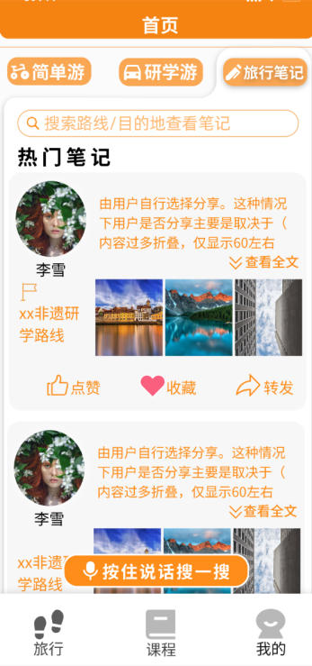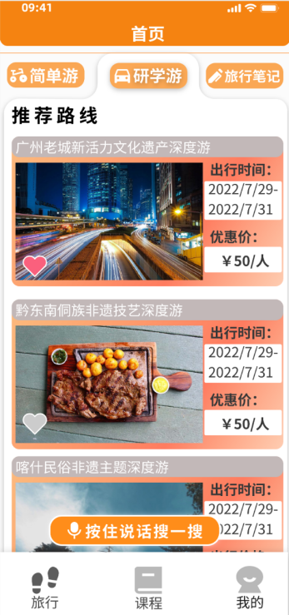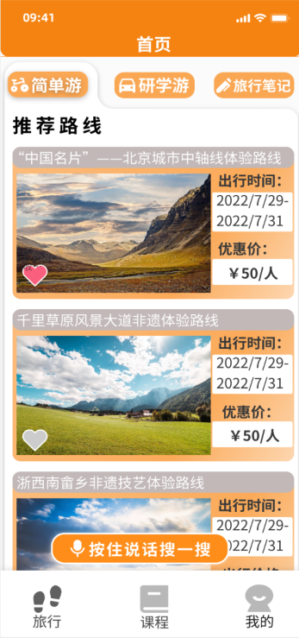

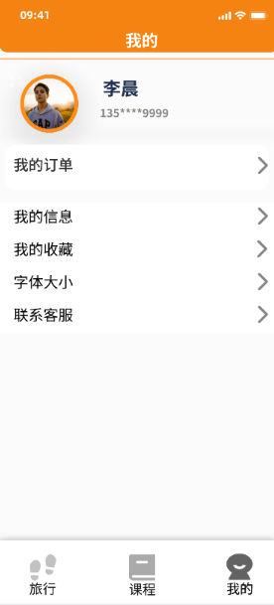

Second Interface

From the recommended routes on the homepage, users can click into the route introduction interface, and then view exciting comments and detailed itinerary arrangements.

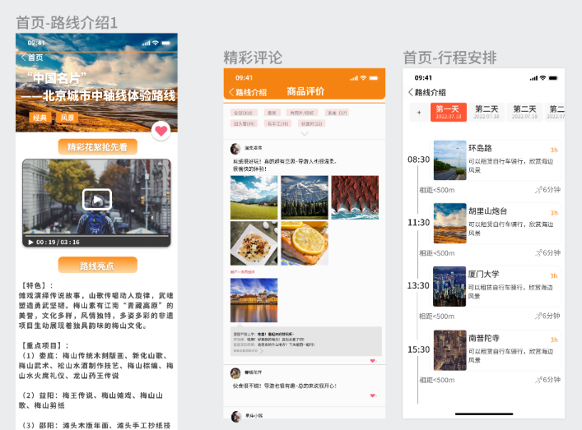

In the Courses section, users can make their own selections. We have made nine main categories related to ICH: Cantonese cuisine, Cantonese embroidery, Cantonese opera, Choi Lee Fut Fist, Wing Chun Fist, paper cutting, Canton silk, woodblock New Year pictures, and more. By clicking on the main categories, users can view specific courses such as "Poached Chicken", and we provide detailed content for users to refer to.

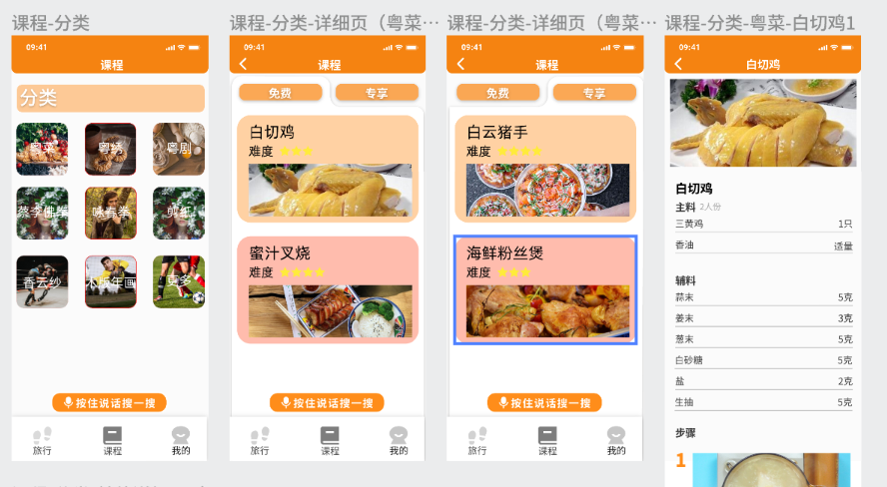

In "My Profile", users can fill in their names, account numbers, and phone numbers. In the future, we may develop WeChat binding login, making it more convenient for the elderly.

1. **Key Technologies**

Kotlin Language: Kotlin is a modern programming language, specifically designed for developing Android applications. It is characterized by its simplicity, safety, and strong expressiveness, which can improve development efficiency and code quality.

Android Framework: The Android framework provides a rich set of APIs and tools for all aspects of building Android applications, including user interface, data storage, network communication, and more.

Android Studio Tools: Android Studio is the officially recommended Integrated Development Environment (IDE) for Android application development. It offers a rich set of tools and features to support Kotlin language development. Android Studio provides tools such as the Kotlin plugin, code auto-completion, debugger, layout editor, etc., making Kotlin development for Android applications more convenient and efficient.

Version Control: In this development, we adopted Git for version control. In a collaborative software development project, version control is crucial. It ensures teamwork by allowing each developer to have a complete local copy of the code repository, and can carry out commit, branch, and merge operations without connecting to a central server.

1. **Testing and User Experience Analysis**

1. Unit Testing: Unit testing will be conducted to test individual components of the app, such as functions and methods. Each component will be tested in isolation to ensure they function as expected.

2. Integration Testing: After unit testing, integration testing will be performed to check how different components interact with each other and the system as a whole. This will help identify issues that could arise when different components interact.

3. Functional Testing: This involves testing the app's functionalities to ensure it meets the requirements specified. This includes testing user interactions like registration, login, browsing content, course enrollment, and so on.

4. Usability Testing: This will involve testing the app's user interface and experience to ensure it's easy to use, especially for the elderly users who are the target demographic.

5. Performance Testing: The app’s performance will be tested under different network conditions and on different devices to ensure it performs well in real-world scenarios.

6. Security Testing: Security testing will be conducted to identify any vulnerabilities that could be exploited and to ensure that user data is securely handled and stored.

By implementing a comprehensive testing strategy, we aim to deliver a high-quality app that provides a robust, secure, and user-friendly experience.

Overall,with the intergation of WeTest which is a third-party detection instituion, we test 4 equippments which were 4 different Oppo Phone to test our application in Andiord environment.There are three reports that I will should in the following content. First of all， When we look at the time to install and time to start the application we can find out that the application need a lot of time to install but not so much time to start which is our character in our current stage.

Second， when we look at the Compatible with successful device distribution， we can find out that all of our equipments are capable of finishing the test succssfully.

Thirdly, when we look at the overall test overview, we can find out the passing rate can reach at 100 percent and the results of the test is fine and perfert.

After reviewing many suggestions from our users we put in over 10 qustionairres to many old people around us and we select them after organzing a meeting and asking them self by self and we conclude several following points: First, the old people we selected information are all beyond 60 and below 80 which is effective selected group. Second, we set up a rating mechanism which we let old people to rate our application by their satisfaction from 0 to 100 and most of them rate our application in ranges between 80 to 90 which show their overall satisfaction in a high level. Third，we set up two questions to check whether our designed outcomes are towards the elderly and how they feel or their experiences of our application, and we find out that the outcomes are demonstrated that the elderly can fit in well with our application and about 70% of them rated our application as “good” and 20% of them rated our application as “ very good”.

When it comes to the feedbacks within our interview with the elderly, they gave us three suggestions to improve our experiment: First, we should improve the settings of the background color and we should choose the colors that are more suitable for them to look through. Second, we should improve function of the interaction buttom.Third, we should add more fuctions that they can share their routine through outer app like WeChat. In conclusion， with the given feedbacks, we set up 2 goals, we want to improve all our functions by getting more suggestions and try to make our application appear on the market.

1. **Future Plans and Sustainability**

The initial launch of the app is just the first step. In order to ensure its sustainability and continued relevance, we plan on regularly updating the app with new content and features, guided by feedback from users. We'll also continue to build partnerships with more non-profit organizations and educational institutions to broaden the range of resources and opportunities available to our users.

A significant aspect of our future plans includes expanding to other platforms, such as iOS and web, to reach more users. This will also involve continuing to refine the app's design to ensure it remains easy-to-use and accessible for our elderly user base.

To finance these future developments and ensure sustainability, we plan on implementing a model that includes income from partnerships, sponsorships, and potentially premium features or services. However, the core educational functionalities of the app will remain free to use for all users.

By focusing on continual growth, user feedback, and diversified income streams, we aim to ensure the long-term success and impact of this app in providing elderly users with access to invaluable cultural and educational resources.

1. **Conclusion**

In conclusion, the creation of this Intangible Cultural Heritage (ICH) educational platform for the elderly has been a significant and rewarding undertaking. The app has successfully established itself as a pivotal bridge between elderly users and ICH culture, offering a wealth of resources and social interaction opportunities.

The primary achievement of the project lies in its empowerment of the elderly community. Through the app, elderly users have access to a rich and diverse selection of ICH education courses, activities, and social features. The app, by promoting interactivity and continuous learning, plays an important role in reshaping the societal role of the elderly, ultimately addressing issues related to aging.

The development process of this app has not been without its challenges. The primary challenge we faced was designing an interface that was both engaging and easy-to-use for our elderly users. Other challenges included ensuring the security of user data, and effectively managing the substantial volume of content in order to provide personalized recommendations.

Looking ahead, we plan to focus on refining the user interface based on feedback and usability tests to make the app more intuitive for our users. We will also continue to strengthen our security measures to ensure the safety of our users' personal data. Our team plans to incorporate more advanced algorithms and artificial intelligence to better manage the content and provide even more personalized recommendations.

Moreover, we foresee expanding our app to other platforms, such as iOS and web, to reach more users. Financing these future developments will involve exploring income from partnerships, sponsorships, and potentially premium features or services, while maintaining the core educational functionalities free for all users.

Overall, the journey of developing this app has been filled with valuable experiences and learnings. As we move forward, we are committed to overcoming challenges and continuously improving our platform to serve the elderly community better and play our part in preserving Intangible Cultural Heritage.